
TEST REPORT
Brazed Plate Heat Exchanger
ToCH Canada

Test Report
№2003JS007 Page 1/6
Description | Brazed Plate Heat Exchanger |  |  | Specifications | B3-12-20-3.0
Description |  |  |  | Brand | /
For | ToCH Canada |  |  | Test Type | Entrusting Test
Sampling place | / |  |  | Date of Sampling | May 27th, 2003
Sample Quantity | 1 piece | Sampling  Radix | / | Sample Sender | /
Prototype No. | / |  |  | Sample No. | 2003HR009
Test Gist | GB 16409-1996 Plate Heat Exchanger  JB 8701-1998 Refrigeration-purpose Plate Heat Exchanger
Test Item | The hot working performance of heat exchanger in Water-to water test  The flow resistant property and the burst pressure.
Test Result | After testing according to GB 16409-1996 Plate Heat Exchanger and JB 8701-1998 Refrigeration-purpose Plate Heat Exchanger, we educe:  1. The relation expression for heat transfer coefficient and coldwater flow velocity: K=11859•W_{c}^{0.313} (W/m² •K) (while W_{h}=0.992m/s)  2. The relation expression for pressure drop and water flow velocity:  P_{w}=0.1478• W_{w}^{1.9353} (MPa)  3. The burst test is 15.5MPa.  ToCH Canada  Date: July 10th, 2003
Remarks | -

ToCH Canada

Test Report
№2003JS007 Page 2/6

Test Date: June 5,2003- June 6, 2003
I. Prototype Briefing
Prototype Type | Brazed Plate Heat Exchanger
Prototype Specifications | B3-12-20-3.0
Plate Type | Chevron Wave
Plate Clearance (mm) | 2.0
Plate Thickness (mm) | 0.3
Plate Quantity (pcs) | 20
Effective Heat Exchange Area of A Single Plate (m²) | 0.012
Total Heat Exchange Area (m²) | 0.216
Hot Water Side Route Section (m²) | 0.0014 (ten routes)
Cold Water Side Route Section (m²) | 0.00126 (nine routes)

II. Test Purpose
1. Test the heat transfer property of the heat exchanger and give relation curve and expression for heat transfer coefficient and water flow velocity.
2. Test the flow resistant property of the heat exchanger and give relation curve and expression for pressure drop and relevant water flow velocity.
3. Test the burst pressure.

III. Test Set and Method
The test is conducted in accordance with the requirements for hot working test in GB 16409-1996 Plate Heat Exchanger. The test set employed is the “Water-to-water Heat Transfer Test Bed” in the testing center.
- Test media: hot media-water, cold media-water
- Test method:
In order to test the heat transfer property of the prototype, fix the hot water flow and temperature of inlet on hot water side and adjust the cold water flow in accordance with requirements of GB 16409-1996 Plate Heat Exchanger. After operation for a certain time when each parameter is stable, make test and measure parameters at such point of work condition. Then adjust the coldwater flow to another point of work condition, make measurements in turn.
Then test the pressure drop;
At last, make burst test in accordance with JB 8701-1998 Refrigeration-purpose Plate Heat Exchanger Appendix B and Rules for Burst Experiment of Brazed Plate Heat Exchanger. Record the burst test pressure.

IV. Computation and Reduction of Test Data
- For test data and computed data, see Sheet 1, Sheet 2 and Sheet 3;
- For relation curve and expression for heat transfer coefficient and coldwater flow velocity, see Fig. 1
- For relation curve and expression for pressure drop and water flow velocity, see Fig.2.
ToCH Canada

Test Report
№2003JS007 Page 3/6

Sheet 1. The data of the Burst Experiment of the Brazed Plate Heat Exchanger

Intermit Pressure | Leaking Position
15.5MPa | Inside

Sheet 2. The data of the Flow Resistant Property Experiment of the Brazed Plate Heat Exchanger

Number | The Cold Water Side (nine routes)
Number | Flow Capacity | Flow Velocity | Pressure Drop
Number | M³/h | m/s | MPa
1 | 1.10 | 0.243 | 0.099
2 | 1.28 | 0.282 | 0.014
3 | 1.78 | 0.392 | 0.025
4 | 2.14 | 0.472 | 0.034
5 | 2.58 | 0.569 | 0.045
6 | 2.96 | 0.653 | 0.063
7 | 3.67 | 0.809 | 0.105
8 | 4.15 | 0.915 | 0.125
9 | 4.54 | 1.001 | 0.149
10 | 4.84 | 1.067 | 0.167

ToCH Canada

Test Report
№2003JS007 Page 4/6
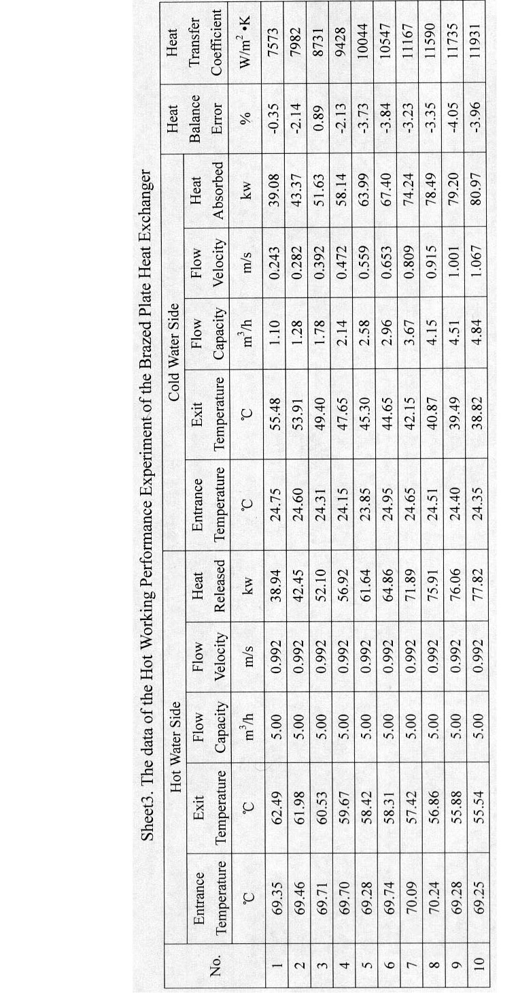
ToCH Canada

Test Report
№2003JS007 Page 5/6

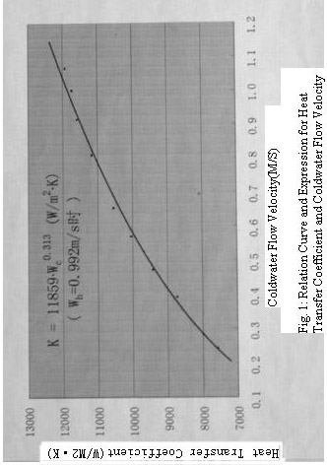

ToCH Canada

Test Report
№2003JS007 Page 6/6

